International seminar in Poland 10 – 16.04.2016
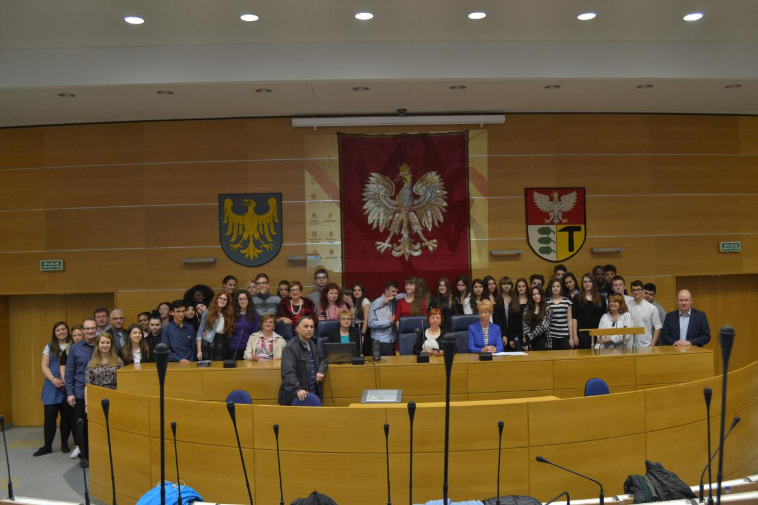
Photo 1. All the participants of the seminar in the lecture hall.
On 13.04.2016 an international seminar for the Erasmus Plus project took place and dealt with the problem of social inclusion, particularly the definition of inclusion on the grounds of ethics, law, social sciences and politics. The first part of the seminar included the lecture on social inclusion by professor Krystyna Faliszek from the Sociology Department of the University of Silesia. In the second part of the event the students from the partner schools presented the results of the work they had been assigned at the start of the project on the theoretical assumptions about social inclusion:
- The distinction among inclusion, integration, exclusion and separation.
- The definition of inclusion.
- The historical development of the concept of inclusion.
- Legal requirements and human rights.
- Inclusion from the ethical point of view.
- Political impact of the UN conventions.
- Structural and social conditions and prerequisites.
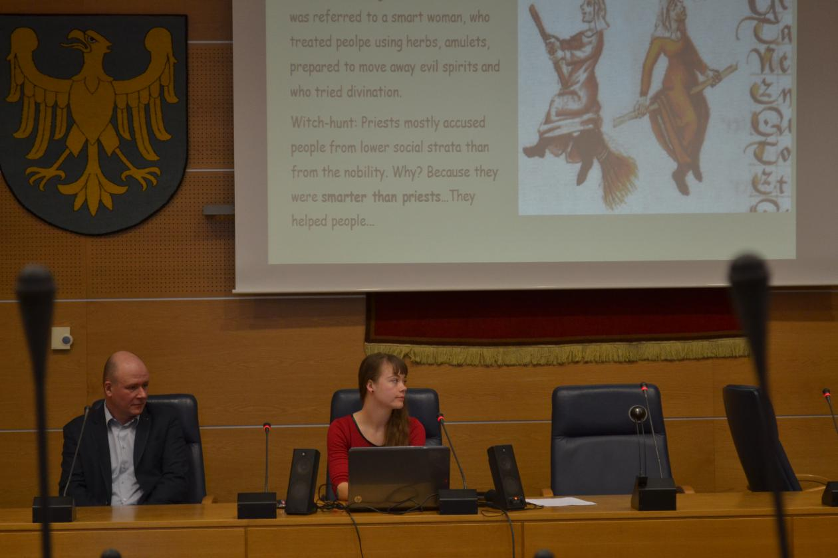
Photo 2. One of the students presenting their work.
The lecture was crucial to the understanding of the whole concept of social inclusion. Its summary is presented below.
Exclusion and Inclusion are two inseparable aspects of the same problem. If we are to describe inclusion and say how important it is and how to achieve it we have to understand social exclusion first.
Social exclusion is the inability to participate in various aspects of social life at a level which is expected and perceived as standard in a given country. Social exclusion manifests itself in three areas: economic, cultural and political.
In the economic area exclusion results from a limited access to the labour market as a consequence of inappropriate education, low qualifications, wrong attitudes and expectations and also due to an illness, disability or being an racial, religious, cultural minority.
It is connected with constant experience of multidimensional inability to satisfy one's needs, mainly the basic material ones but also those of a higher degree. Such a situation leads to frustration, which may result in violent behaviour.
The cultural aspect of exclusion means that different strategies for adjusting to social life are used, different to what most citizens accept as appropriate. It usually manifests itself in alternative system of values, role models, attitudes, lifestyle, which are inherited by subsequent generations.
The political aspect of exclusion refers to the lack of access to power, i.e. the inability to express one's interests, to create one's own lobby groups to support those interests, to shape the public opinion. It usually means that an individual refuses to participate in the political life e.g. vote in general elections. Such an individual openly declares their disinterest and discouragement, but it frequently result from the lack of basic knowledge abou the principles of a democratic state. Political exclusion most often results from economic an cultural exclusion.
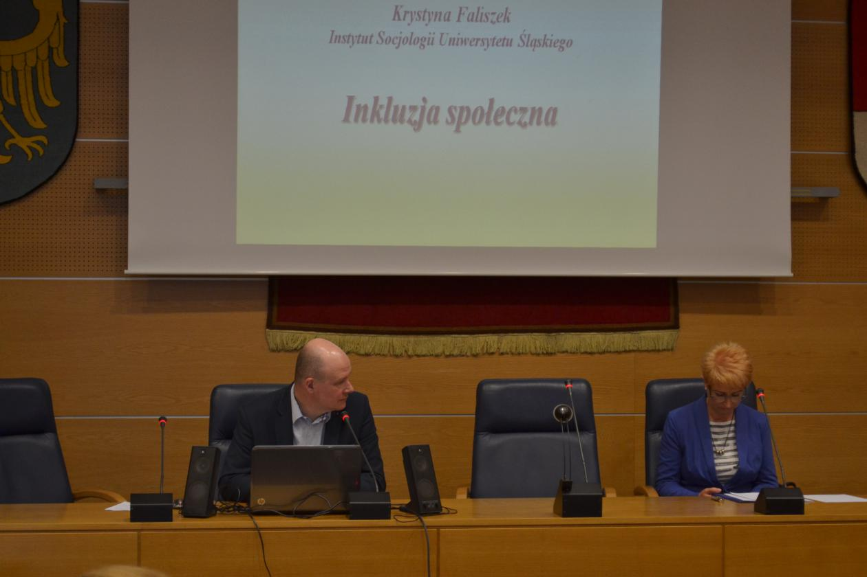
Photo 3. The university lecturer giving a speech.
Exclusion means the inability to participate in various aspects of social life, which allows to cope with problems and difficult situations of life. The process of adjusting to this inability leads to the rise of further problems such as addictions, dependance of state support, malfunction of family, crime, passiveness, acquired helplessness. The next generation inherits those norms, values and behaviour models that result from the adjustment to social exclusion.
A specific result of social exclusion is the acquired helplessness, which means no control over one's own life and the surroundings. Experiencing constant failures leads to the assumption that one does not have any influence on what happens to them and their family, it all depends on some external powers: fate, destiny and the mythical "them". People lose motivation to undertake any efforts to change their life. This results in attitudes called "demanding".
The problem of social exclusion is common among the developed countries. It refers not only to individuals, but also to whole social groups. It must be clearly stated that social exclusion does not mean the loss or lack of any rights or privileges or no access to them, but the inability or loss of the ability to implement all those rights and privileges.
Why does social inclusion occur:
- social gaps increase, which leads to conflict,
- the division of labour increases (unemployment, job insecurity)
- the development of the mass society, where the mass media promote uniform goals and success models
- economic, social and cultural globalisation (workplaces are moved to cheap-labour countries)
After the second world war the relatively well developed and rich countries created the welfare-state, which involved a high degree of the state intervention in economic processes in order to ensure the citizens’ well-being and the democratic system. Due to favourable economic growth a network of social rights and guarantees was created thanks to high social expenditure. Such a system deprived people of their own initiative, made them passive, unable to cope with difficult situations and dependent on state support. All that leads to social exclusion.
Participation is the pillar of the civic society and it means that citizens undertake action in order to ensure the common well-being. Social exclusion is the opposite of participation and poses threat to the democratic system and the state.
That is why one of the key goals of the EU social policy is inclusion or engaging those excluded individuals and social groups in participation. Increased social integrity due to social and professional activation is a priority of the social policy as an answer to the economic restructuring.
The new model of the active social policy is counteracting the greatest problem of the welfare state: passiveness and helplessness of the citizens dependent on the state support. Social inclusion improves the quality of life not only among the excluded, but the whole society, strengthens the civic democracy and make the state function better.
Inclusion is the process where the excluded citizens get their ability to participate in social life back, regaining their independence, ability to choose and the opportunity to play various social roles. Inclusion means rebuilding social relations with the society, incorporating the excluded ones into the network of social exchange.
The key aspect of being socially excluded is unemployment and difficulties in returning to the labour market, so inclusion is mainly connected with activities aimed at professional activation. However, they need to be accompanied by activities targeted at social activation: independence, self-reliance, the ability to utilise one’s own resources to generate changes in one’s own life.
There are a lot of examples of such activities realised in Poland. Continuous social work, performed not only by the state institutions, but also by non-government bodies, helps people out of unemployment, homelessness, addictions, builds a system of support that allows those people to settle down and be responsible for their own lives. Successful tools include local activity projects, social cooperatives, self-support campaigns, social integration centres and social economics.
The lecture was supplemented by the representative of the local social work centre who presented one of her recent projects aimed at inclusion of unemployed women and convicts by engaging them professionally. It proved that inclusion can be achieved and gave the seminar participants a practical insight into the problem.

